Activation functions are mathematical functions that are used in neural networks to introduce non-linearity into the model. Here are some of the important activation functions, their graphs, and their use cases:

1. **Sigmoid function:**

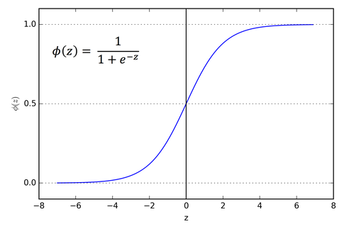

The sigmoid function takes a real-valued number as input and maps it to a value between 0 and 1. It is useful in binary classification problems, where the output is either 0 or 1. The sigmoid function can also be used as a gate to control the flow of information in a neural network.

1. **ReLU function:**

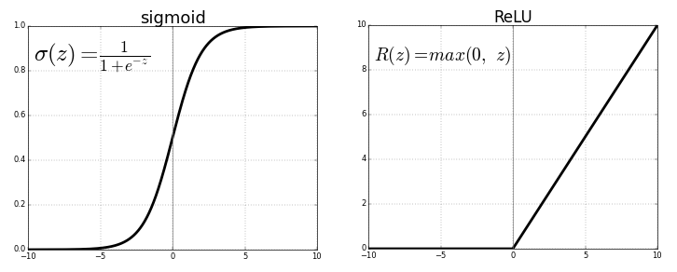

The ReLU (Rectified Linear Unit) function takes a real-valued number as input and returns the maximum of 0 and the input. It is the most commonly used activation function in deep learning. The ReLU function is used to introduce non-linearity into the model and to speed up the convergence of the gradient descent algorithm. It is useful in both regression and classification problems.

1. **Tanh function:**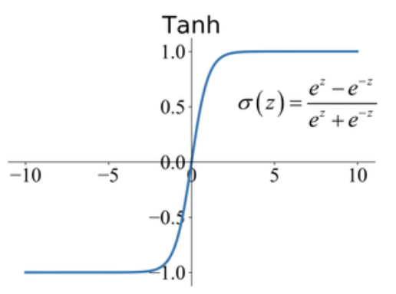

The tanh function takes a real-valued number as input and maps it to a value between -1 and 1. It is useful in neural networks for regression and classification problems. The tanh function is similar to the sigmoid function, but its output ranges from -1 to 1.

1. **Softmax function:**

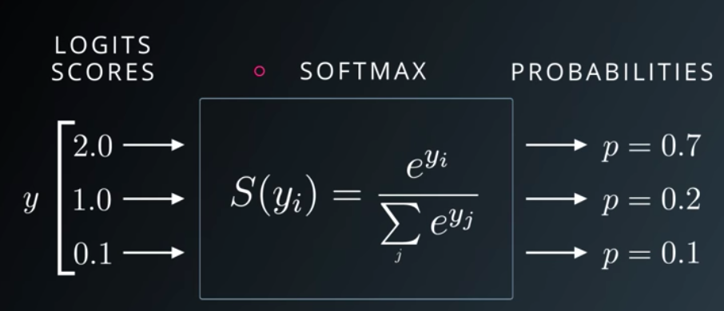

The softmax function takes a vector of real-valued numbers as input and maps it to a probability distribution. It is useful in multi-class classification problems, where the output is one of several possible classes. The softmax function normalizes the outputs of the neural network to a probability distribution, so that the sum of the probabilities is equal to 1.

1. **Leaky ReLU function:**

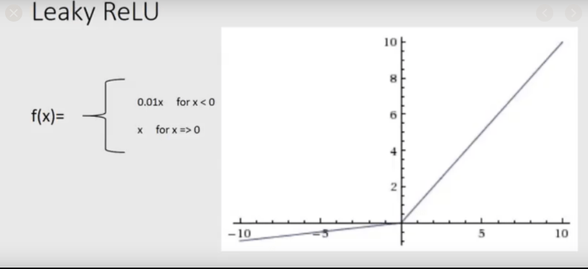

The Leaky ReLU function is similar to the ReLU function, but it allows a small, non-zero gradient when the input is negative. This can help to prevent the problem of "dying ReLU", where a large fraction of the neurons in the network become inactive and do not contribute to the output. The Leaky ReLU function is useful in deep neural networks with many layers.

1. **ELU function:**

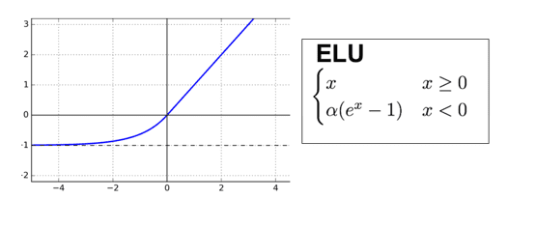

The ELU (Exponential Linear Unit) function is similar to the Leaky ReLU function, but it saturates to a negative value when the input is small. This can help to improve the robustness of the neural network to noisy input data. The ELU function is useful in deep neural networks with many layers.

These are just a few examples of the many activation functions that are available for use in neural networks. The choice of activation function depends on the specific problem and the properties of the data that is being used